**LAST CHRISTMAS**

Last Christmas, I gave you my heart  
But the very next day you gave it away  
This year, to save me from tears  
I'll give it to someone special

Last Christmas, I gave you my heart  
But the very next day you gave it away  
This year, to save me from tears  
I'll give it to someone special

Once bitten and twice shy  
I keep my distance  
But you still catch my eye  
Tell me, baby  
Do you recognize me?  
Well, it's been a year  
It doesn't surprise me  
(Merry Christmas!) I wrapped it up and sent it  
With a note saying, "I love you, " I meant it  
Now, I know what a fool I've been  
But if you kissed me now  
I know you'd fool me again

Last Christmas, I gave you my heart  
But the very next day you gave it away  
This year, to save me from tears  
I'll give it to someone special

Last Christmas, I gave you my heart  
But the very next day you gave it away  
This year, to save me from tears  
I'll give it to someone special

A crowded room, friends with tired eyes  
I'm hiding from you, and your soul of ice  
My god, I thought you were someone to rely on  
Me? I guess I was a shoulder to cry on

A face on a lover with a fire in his heart  
A man under cover but you tore me apart  
Now, I've found a real love you'll never fool me again

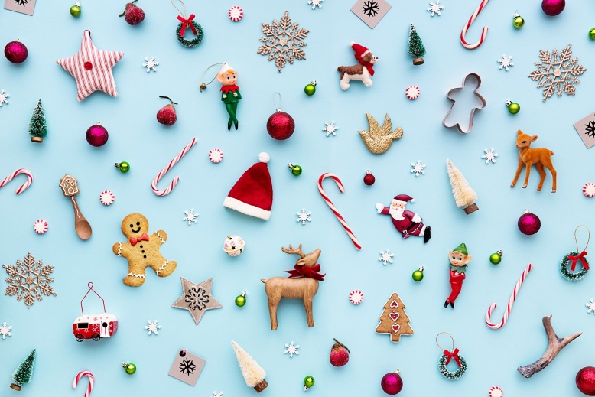Last Christmas, I gave you my heart  
But the very next day you gave it away  
This year, to save me from tears  
I'll give it to someone special

Last Christmas, I gave you my heart  
But the very next day you gave it away  
This year, to save me from tears  
I'll give it to someone special

A face on a lover with a fire in his heart  
A man under cover but you tore him apart  
Maybe next year I'll give it to someone  
I'll give it to someone special

Source: