**WE WISH YOU A MERRY CHRISTMAS**

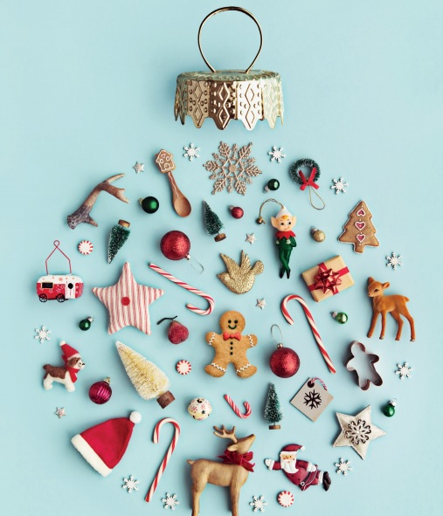We wish you a Merry Christmas  
We wish you a Merry Christmas  
We wish you a Merry Christmas and a happy New Year  
Good tidings we bring to you and your kin  
We wish you a Merry Christmas and a happy New Year

Oh, bring us some figgy pudding  
Oh, bring us some figgy pudding  
Oh, bring us some figgy pudding  
And bring it right here

Good tidings we bring to you and your kin  
We wish you a Merry Christmas and a happy New Year  
We won't go until we get some  
We won't go until we get some  
We won't go until we get some  
So bring it right here

Good tidings we bring to you and your kin  
We wish you a Merry Christmas and a happy New Year  
We all like our figgy pudding  
We all like our figgy pudding  
We all like our figgy pudding  
With all its good cheers

Good tidings we bring to you and your kin  
We wish you a Merry Christmas and a happy New Year  
We wish you a Merry Christmas  
We wish you a Merry Christmas  
We wish you a Merry Christmas and a happy New Year